Nurturing Relationship Informed Policy | SAINT FINIAN’S NATIONAL SCHOOL

Nurturing Relationship Informed Policy
Saint Finian’s National School is working towards becoming a Nurture, Relationship Informed school where positive, thinking relationships between the child and adult, between child and child and between adult and adult are seen as nurturing of learning, healing and development.
Underlying principles: An understanding of attachment theory – that the child learns a sense of self and others first through the relationship with primary carers and, where this is an ‘attuned’ relationship; i.e. where the primary carer is responsive and able to interpret and satisfy the child’s needs and to nurture a readiness to learn and to mark and celebrate success in learning. We continue to learn and develop in relationships, throughout our lives. A key concept of attachment theory: ‘Containment’ is reflected in this policy. The school should aim to be a secure base for the child where they can feel safe to explore, learn and form positive relationships.
Containment; whereby the caregiver/ mother absorbs overwhelming emotions such as anxiety , uncertainty, frustration and stress, thinks about them and gives them back in a way the child can absorb… The concept of containment of anxiety can also be adapted to institutional practice and the organisation and practices of a school can be experienced as ‘containing’. Geddes p 39, 40
Bowlby (1988) maintained that all of us, from the cradle to the grave, are happiest when life is organised as a series of excursions, long or short, from the Secure Base provided by our attachment figures. P 38 Geddes – Attachment in the classroom.
Trusting, nurturing relationships within school not only create a secure base but will support the cognitive, social and emotional development of the child. This school recognises that early infant and childhood experiences of adversity and trauma can impact on the physical, cognitive, social and emotional development of the child. Seeing behaviour as communication and seeking to understand the meaning behind challenging behaviour is fundamental to our attachment and trauma aware school, a school that is committed to developing core nurturing relationships. Our school focuses on building positive, open and emotionally communicative relationships where each member of the school community; adult or child, can thrive, feel safe and valued and achieve their potential. The school acknowledges that some pupils will require additional, creative and sometimes individual support and accommodations and that becoming a Nurturing Relationship Informed school will foster a sense of belonging, certainty and self-worth within the safety, predictability and clear structures of school.

Implementation strategy:
- There is a whole school approach to development as a relationship for nurture school. This involves; training, visual displays, explicit teaching and assigned roles and responsibilities.
- In order for school staff to effectively build relationships with pupils and parents or carers, they need to prioritise their own emotional well-being and staff relationships. Time will be built in for this (through Croke park hours, staffroom organisation and school communication systems -responsibility of ISM – Maureen Fitzpatrick) promoting reflective practice and a positive, collaborative school culture. The ISM of Saint Finian’s National School will arrange at least one self-care training or support event each term for all staff, (attendance at which is strongly encouraged but not compulsory.) School staff will be kept informed of external agencies and supports that they can avail of for their well-being, e.g. the number for the Employee Assist service (Inspire), Better Finglas, community supports and in-school mentors displayed on staff noticeboards. There will be a systemic and team approach in working with the children whose additional needs in this have been identified or which come to light following an incident. There will be clearly defined roles for the supporting teachers and SNAs in pupils’ care plans, such as key adult role as outlined in LM Bomber’s book Inside I’m hurting. There will be in-school mentoring for the adults working with them.

- Saint Finian’s National School will undertake annual whole school CPD in attachment and trauma awareness, including self-care. All members of staff, including ancillary staff and BoM will attend. Ancillary staff are not compelled but will be offered this training and will be familiarised with the contents and implications of this policy on all aspects of school life including their work. Senior school staff / the ISM will be involved in ongoing leadership training in this area and will ensure that new and temporary staff will have access to training and mentoring in ATA. Responsibility for leading this rests with Maureen as part of the ISM / special duties post.

- Continuity of engagement in Relationships for Nurture development: Relational approaches in school will be a standing item on staff meeting agendas and key school documents such as the school plan/ DEIS plan, SPHE programme and SEN policies will be reviewed through the lens of attachment and trauma awareness. Care plans for pupils will ensure that security and the development of a trusting and nurturing relationship with at least one key adult at school are priority targets as well as supporting a sense of belonging at school and commitment to support holistic learning. Opportunity to discuss implementation with the other schools in this cluster will be offered annually to the in school management teams and possibly the whole staff, where practical.
- Use of attachment and trauma awareness vocabulary. The adoption and consistent integration of the vocabulary of positive relationships and nurture into the everyday language of the school, including policy documents, classroom resources and conversations with pupils will promote a development of the ethos of attachment and trauma awareness and of nurturing, positive relationships with pupils. There will be ready access to books and activities to develop emotional articulacy and language throughout the school. For example, consistently acknowledging the strong emotions such as anger, frustration and fear behind pupils’ behaviour will promote mutual understanding and trust and move away from sanction- based responses by staff. This use of vocabulary will be extended to relationships with parents.
- Ongoing development of Restorative practices and restorative school culture is a key feature of interactions, managing everyday conflict and problem solving in our school and will enable the voice of the child to be heard and contribute to school life.
- Pupils will be directly involved in the implementation of the relationships for nurture school through the exposure to the vocabulary, restorative practices and resources as well as explicit teaching through the SPHE programme, mindfulness practices and nurture resources.
- Learning to trust is a key precursor to learning to learn for all children and those pupils who have been identified by staff or parents or who self identify as having additional needs in this area may have a ‘key adult’ assigned to them. This adult will actively seek to promote a positive and appropriately dependent relationship with the pupil and pay particular attention to ‘trouble shooting’ and to planning for periods of transition and change for the child. The adult will be named in the child’s care plan and role and targets outlined. A plan and perhaps a substitute or second adult will be named for when the key adult is absent or unavailable. The adult will have access to support and self-care as part of this plan. This may be formal or informal depending on resources and need.
- Physical and procedural adaptations to the school environment will support the relationships for nurture throughout the school environment – access to a safe space/ chill out/ nurture rooms, library of resources that focus on emotions and the use of non-verbal cue cards. Staff will also have clear access to safe spaces/ procedures to support their work with very vulnerable pupils. It is the responsibility of all staff of this school to maintain the staff room as a ‘safe and welcoming space’ and to model positive, mutually respectful relationships with other adults in school.
- Ensuring safety for children and adults in the school is paramount to establishment of the school as a secure base. The school will involve pupils, parents and staff in developing and displaying visually clear and positive rules and expectations throughout the school and about all aspects of the school day and activities including coming to and leaving the school building. Explicit teaching of the rules and expectations at age appropriate levels will take place in all classes at the beginning of the school year.
- This policy is supported by the anti-bullying policy, the code of behaviour and is underpinned by the child safeguarding statement. See also the Action plan for seriously disruptive and dangerous incidents involving a pupil with significant additional needs.
- This policy will be reviewed annually in September.

Appendix 1, Tips for implementing a Trauma responsive approach
Use a ‘Trauma Glasses on’ lens to view behaviour: Reference Dr Mary Gordon:

- Differentiate expectations – what is realistic for each pupil, depending on the context.
- Model and explicitly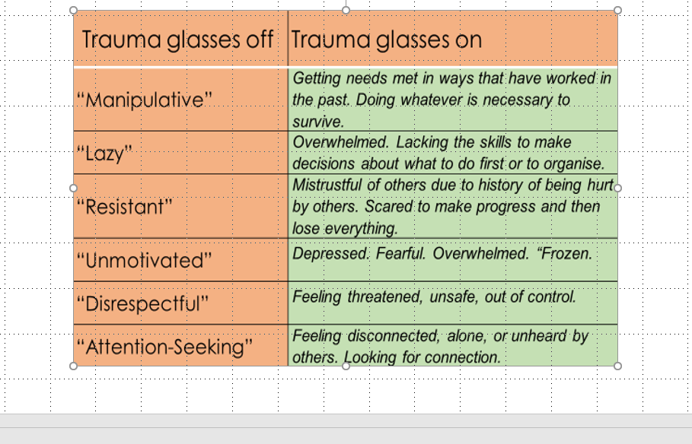 teach what is needed for ‘readiness to learn’.
- Differentiate response to pupils. Use non-verbal cues and gestures and always ensure that any disapproval expressed is of the behaviour and not the person. Avoid shaming approaches – names or groups on clouds/ ladders.
- Relationships first. Connect before you correct. Use emotion coaching and attachment aware scripts; ‘I wonder if you’re feeling…. I know that this may feel scary for you …
- A whole school approach: Attachment and building relationships is everybody’s business. School leaders must lead the ethos to promote a consistent approach that is embedded across the school.
- Use agreed tools for recording, monitoring and sharing planned behaviour support strategies so that they can be consistently implemented.
- Expect and anticipate sabotage from some most vulnerable pupils and ‘ Name it to tame it’ (Dan Siegel, https://www.youtube.com/watch?v=-AJAe28xkvM )
- Recognise that what you feel is a likely indication of how the dysregulated pupil feels. If you feel frustrated, stuck or angry, it is likely that is how the pupil feels and giving lectures or consequences are unlikely to be helpful.

Appendix 2: Emotion coaching is an approach which focuses on the development of emotional regulation through supportive relationships.
The 5 key steps in emotion coaching are:
- Notice the child’s behaviour and tune into the emotion beneath.
- Connect with the child and recognise emotional times as opportunities for intimacy and teaching.
- Listen empathetically and validate the child’s feelings
- Help the child to verbally label emotions
- Set limits on the child’s behaviour whilst helping the child to problem solve.
Reference; https://www.emotioncoachinguk.com
Ch
checklist for review:
1 | How many suspensions have there been in the past school year? |  | Have additional needs come to light from these? If so, what and how can future suspensions be prevented? Who will update IBLP? Who will key adult be?
2 | How many pupils are frequently late, absent, disruptive? |  | As above
3 | How many pupils are noticeably withdrawn, aloof, hard to connect with and clearly under-achieving? |  | As above
4 | Has every pupil been encouraged to complete an Audit of feelings / an age appropriate and accessible checklist of ‘My feelings about school? | Y/ N | If not, can SPHE plan incorporate this during this term?  If yes, has this been assessed and discussed by the class teacher and resource team?
5. | Staff will be encouraged to self-check and reflect on their feelings and understanding of external and internal stressors and reminded of internal and external supports that are available. *** See resource over |  | RCSI Health and Happiness Course resource – self checklist.  RCSI Science of Happiness - PAVING the Path to Wellness.pdf
6. | Was CPD on trauma responsive school offered last year? (How many new members of staff are there? Repeat for them or for whole staff.) | Y/N | Repeat, follow up or identify next step? Who will take responsibility for arranging this?
7 | What self care events are needed this year – Identify one for each term. Aim for a blend of individual mental health protection and team building/ relationship nurture, communication skills focus. |  | Who will organise?
8. | Was there collaboration with other schools/ groups in the community? If so, should this be repeated? |  | Who, what and when to be decided.
9 | Is the language of feelings and relationships evident throughout the school and on the yard? |  | Who has responsibility to develop and improve this? And to ensure that consistent rules and expectation displays are evident.
10 | Are rules and expectations being explicitly taught and clearly evident in displays? |  | Every class teacher takes responsibility for ensuring this happens.
11 | What celebrations are there to promote a sense of achievement in the area of empathy, positive relationships, emotional articulacy, self-regulation and social solidarity? Specify what events or strategies were effective and what needs to be developed. |  | Who has responsibility for this?
12 | Wish list – what more would staff like to see happening as a positive development of the relationships for nurture school ethos and procedures.

*In reviewing the code of behaviour in an ATA school: A behaviourist approach to discipline – system of rewards and sanctions may mean that pupils who have experienced severe trauma and loss rarely experience success in school and indeed may most often be sanctioned, excluded, suspended, further exacerbating their marginalisation and trauma. Relational trauma requires relational repair, therefore every child should feel that the adults in the school are there to support them, no matter what and that the behaviour does not define the child.

Note 2. A behaviourist approach to discipline – system of rewards and sanctions may mean that pupils who have experienced severe trauma and loss rarely experience success in school and indeed may most often be sanctioned, excluded, suspended, further exacerbating their marginalisation and trauma. )

